9. Scenario: You work for a real estate agency and have been given a dataset containing

information about properties for sale. The dataset is stored in a Pandas DataFrame named

property_data. The DataFrame has columns for property ID, location, number of bedrooms, area

in square feet, and listing price. Your task is to analyze the data and answer specific questions about

the properties.

Question: Using Pandas DataFrame operations, how would you find the following information

from the property_data DataFrame:

1. The average listing price of properties in each location.

2. The number of properties with more than four bedrooms.

3. The property with the largest area.

Code:

import pandas as pd

df = pd.read_csv(r"C:\Users\jampa\Downloads\property_data.csv")

avg_price_per_location = df.groupby('Location')['Listing Price'].mean()

print("1. Average listing price by location:")

print(avg_price_per_location)

properties_gt4_bedrooms = df[df['Bedrooms'] > 4].shape[0]

print(f"\n2. Number of properties with more than four bedrooms: {properties_gt4_bedrooms}")

largest_property = df.loc[df['Area (sqft)'].idxmax()]

print("\n3. Property with the largest area:")

print(largest_property)

output:

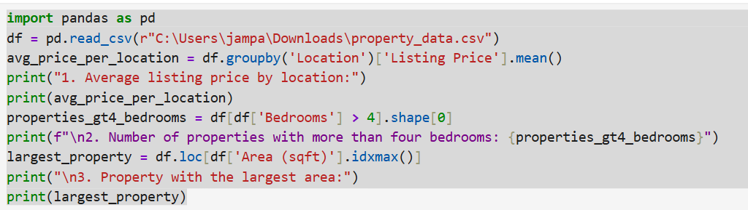

Dataset:

| Property ID | Location | Bedrooms | Area (sqft) | Listing Price |
| --- | --- | --- | --- | --- |
| P1000 | Uptown | 1 | 4384 | 373030 |
| P1001 | Suburb | 2 | 3161 | 111734 |
| P1002 | Suburb | 5 | 3744 | 885619 |
| P1003 | Countryside | 2 | 755 | 122025 |
| P1004 | Suburb | 5 | 4989 | 971361 |
| P1005 | Countryside | 1 | 1239 | 415681 |
| P1006 | Suburb | 3 | 4624 | 805268 |
| P1007 | Suburb | 3 | 1147 | 538995 |
| P1008 | Uptown | 1 | 4990 | 370373 |
| P1009 | Suburb | 6 | 3047 | 918661 |
| P1010 | Downtown | 3 | 1770 | 632275 |
| P1011 | Countryside | 2 | 4038 | 102225 |
| P1012 | Downtown | 3 | 4610 | 689011 |
| P1013 | Suburb | 2 | 2565 | 686207 |
| P1014 | Uptown | 5 | 4454 | 802110 |
| P1015 | Uptown | 4 | 4593 | 424878 |
| P1016 | Downtown | 4 | 3906 | 578262 |
| P1017 | Downtown | 4 | 2946 | 747357 |
| P1018 | Downtown | 6 | 3877 | 570701 |
| P1019 | Beachside | 6 | 4166 | 595284 |
| P1020 | Beachside | 6 | 4484 | 384225 |
| P1021 | Beachside | 4 | 3940 | 164284 |
| P1022 | Beachside | 4 | 1129 | 905991 |
| P1023 | Beachside | 6 | 3713 | 959953 |
| P1024 | Countryside | 4 | 916 | 758676 |
| P1025 | Countryside | 5 | 801 | 718583 |
| P1026 | Uptown | 5 | 2899 | 674186 |
| P1027 | Downtown | 1 | 1684 | 392289 |
| P1028 | Beachside | 3 | 1040 | 234617 |
| P1029 | Uptown | 2 | 2392 | 289949 |
| P1030 | Beachside | 1 | 3913 | 720755 |
| P1031 | Downtown | 4 | 3245 | 392006 |
| P1032 | Downtown | 1 | 4877 | 398314 |
| P1033 | Beachside | 4 | 3286 | 410913 |
| P1034 | Uptown | 4 | 1828 | 709252 |
| P1035 | Suburb | 1 | 1232 | 943908 |
| P1036 | Downtown | 2 | 1275 | 606295 |
| P1037 | Uptown | 2 | 3131 | 393130 |
| P1038 | Beachside | 4 | 4270 | 993872 |
| P1039 | Downtown | 3 | 2781 | 771738 |
| P1040 | Downtown | 5 | 843 | 786022 |
| P1041 | Downtown | 6 | 637 | 561131 |
| P1042 | Beachside | 4 | 2630 | 168340 |
| P1043 | Beachside | 5 | 2794 | 728638 |
| P1044 | Suburb | 3 | 3188 | 776262 |
| P1045 | Beachside | 3 | 1955 | 469456 |
| P1046 | Downtown | 1 | 3912 | 408043 |
| P1047 | Uptown | 3 | 2167 | 102899 |
| P1048 | Countryside | 5 | 3106 | 608864 |
| P1049 | Uptown | 6 | 777 | 153475 |
|  |  |  |  |  |